# Term project

Team members:

Jashanpreet Singh – C0752052 (Team Leader)

Abhishek Sharma – C0752852

Komalpreet Singh- C0753373

Shahnawaz Singh – C0751589

BUSINESS MODLE:

1. **Restaurant Management System**

*Entities:*

Manager, Cook, Client, Table, Menu

*Relationships:*

One manager serves many clients

One client can be served by many managers

One client can be assigned to one table

One table can be assigned to many clients

One cook can prepare many menus

One menu is prepared by one cook

One menu can be served to many clients

One client can be served many menus

Conceptual Model:

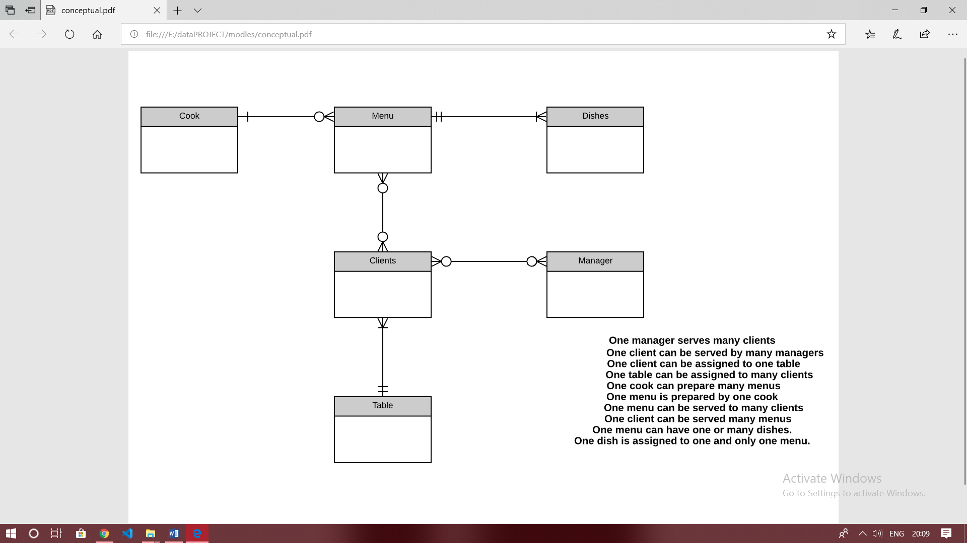

Logical Model:

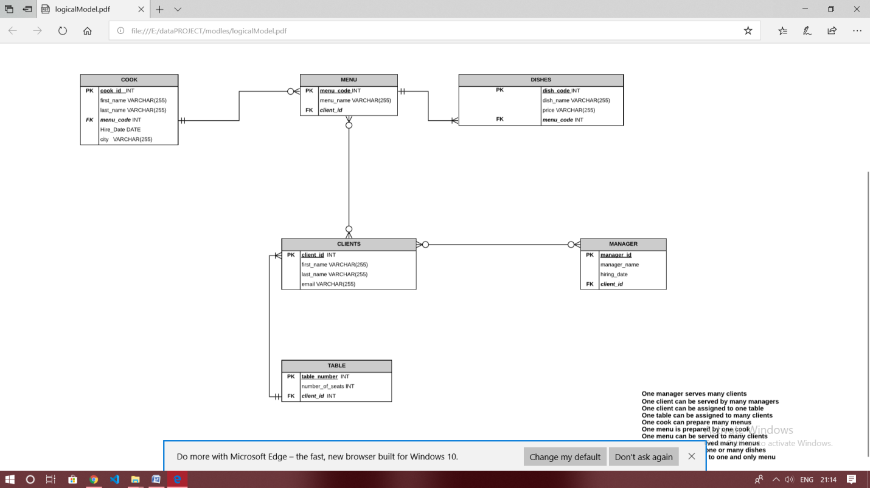

Physical Model

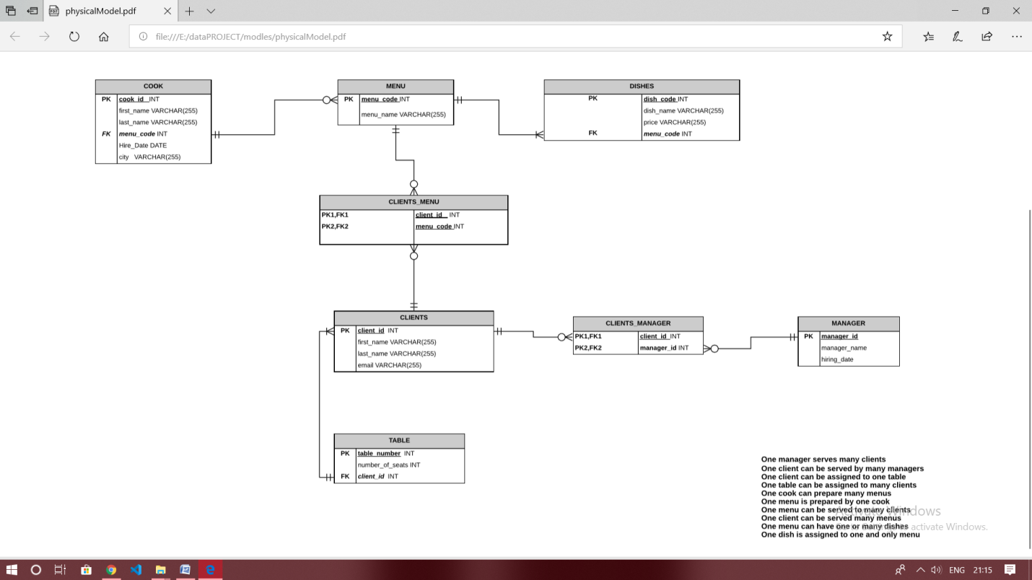

Matrix Table

|  |  |  |  |  |  |  |
| --- | --- | --- | --- | --- | --- | --- |
|  | Cook | Menu | Dishes | Clients | Table | Manager |
| Cook |  | Prepares |  |  |  |  |
| Menu | Is prepared by |  | Have | Served to |  |  |
| Dishes | Has | Has |  |  |  |  |
| Clients |  | Has |  |  | Assigned to | Have |
| Table |  |  |  | Has |  |  |
| Manager |  |  |  | Have |  |  |

QUERIES:

Create Manager Table:

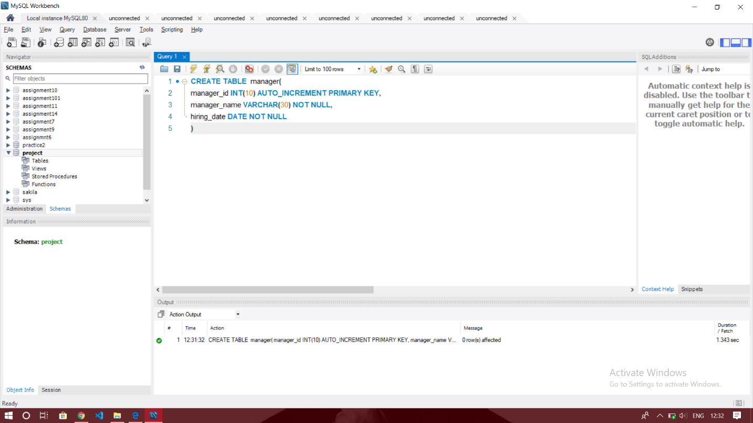

Create menu Table:

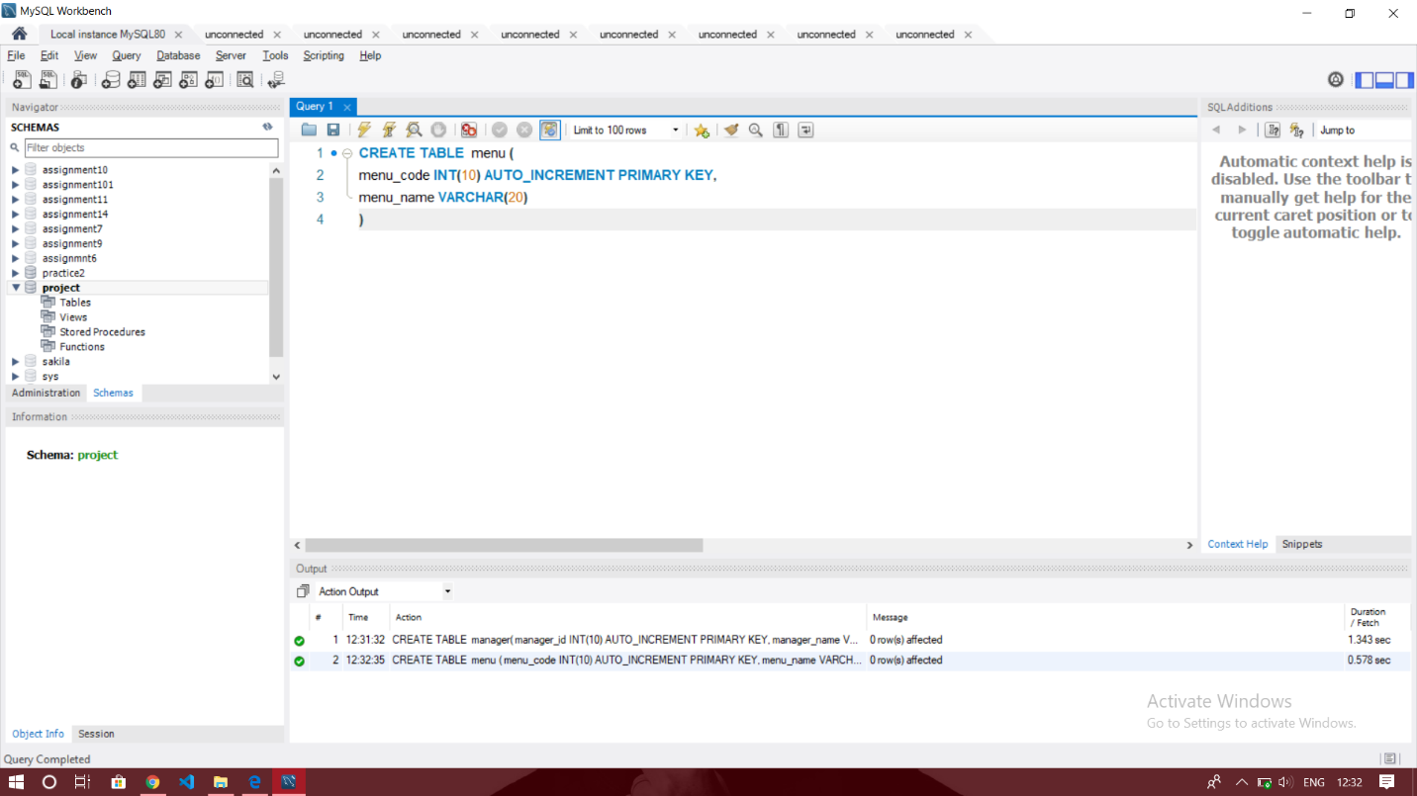

Create dishes Table:

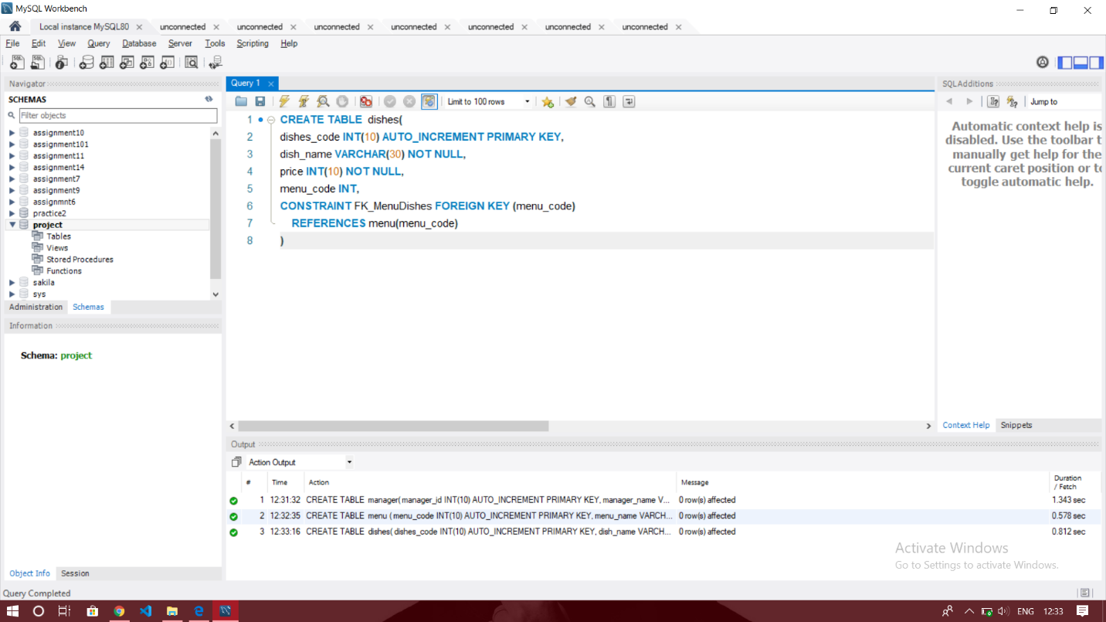

Create cook table:

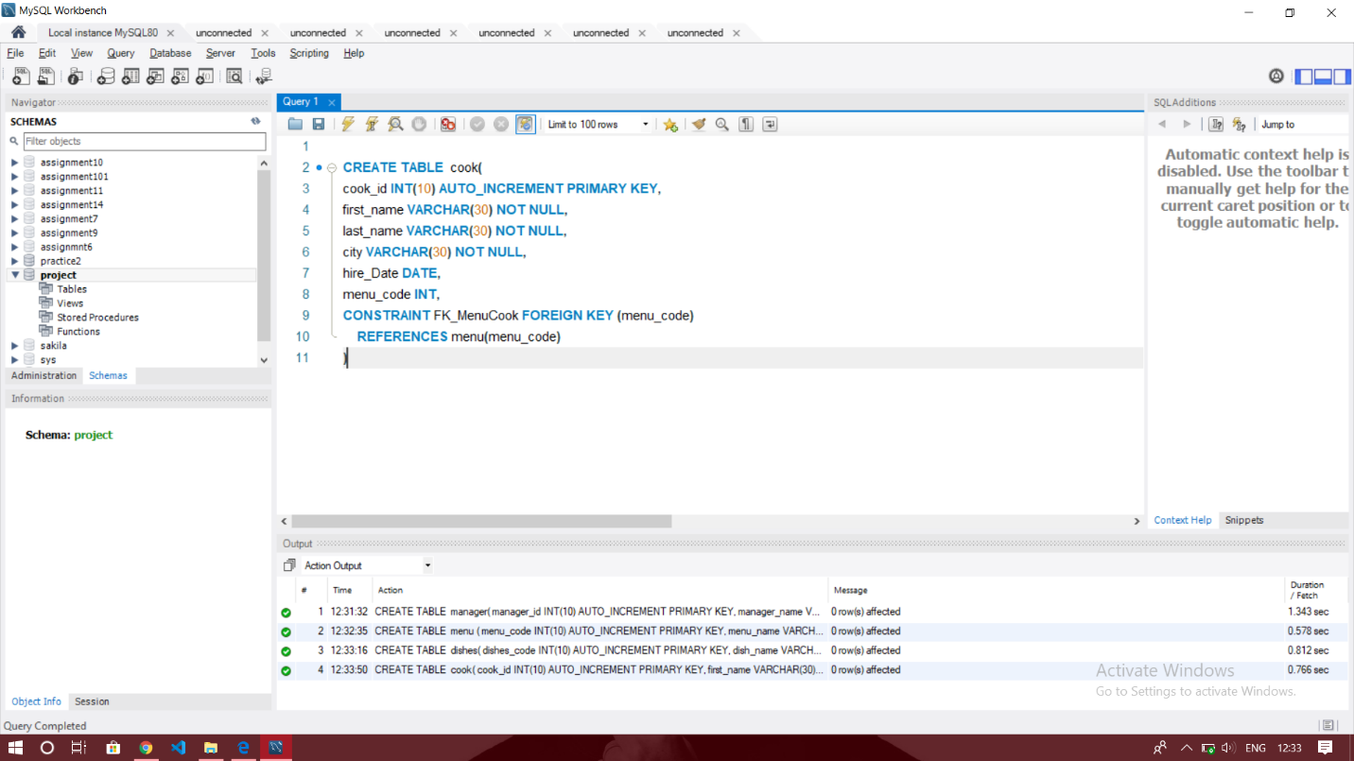

Create client table:

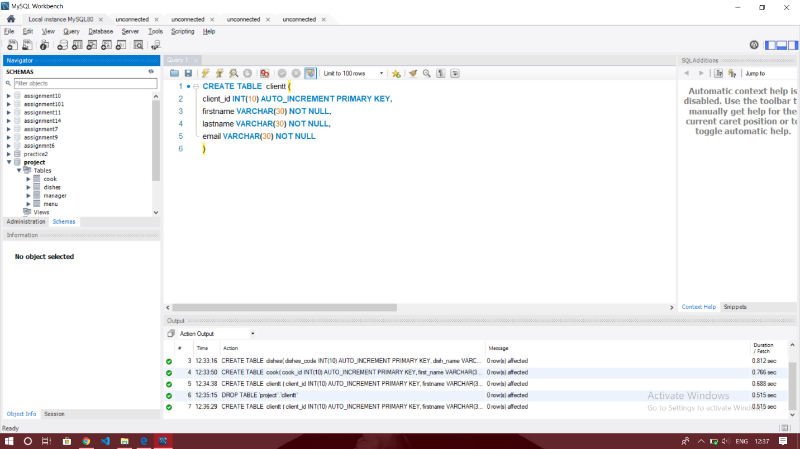

Create clients_manager table:

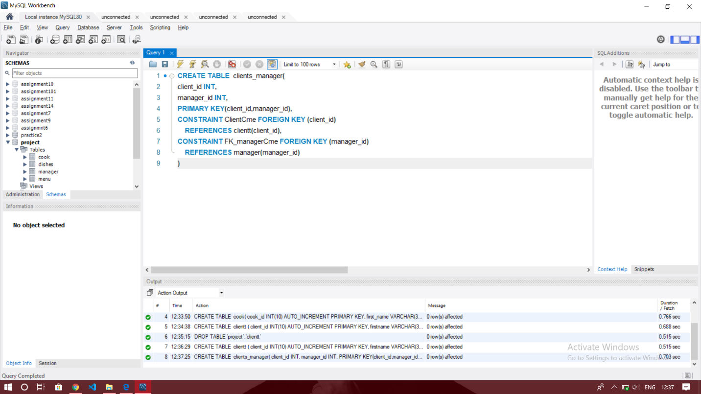

Create clients_menu:

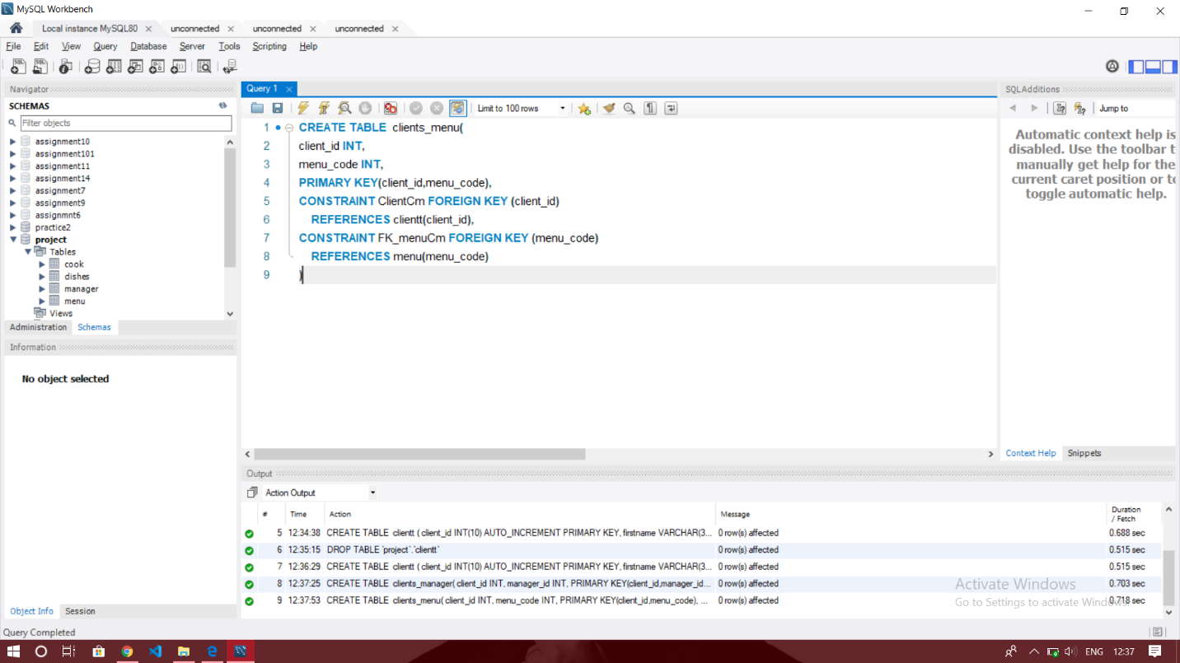

Create tablee Table:

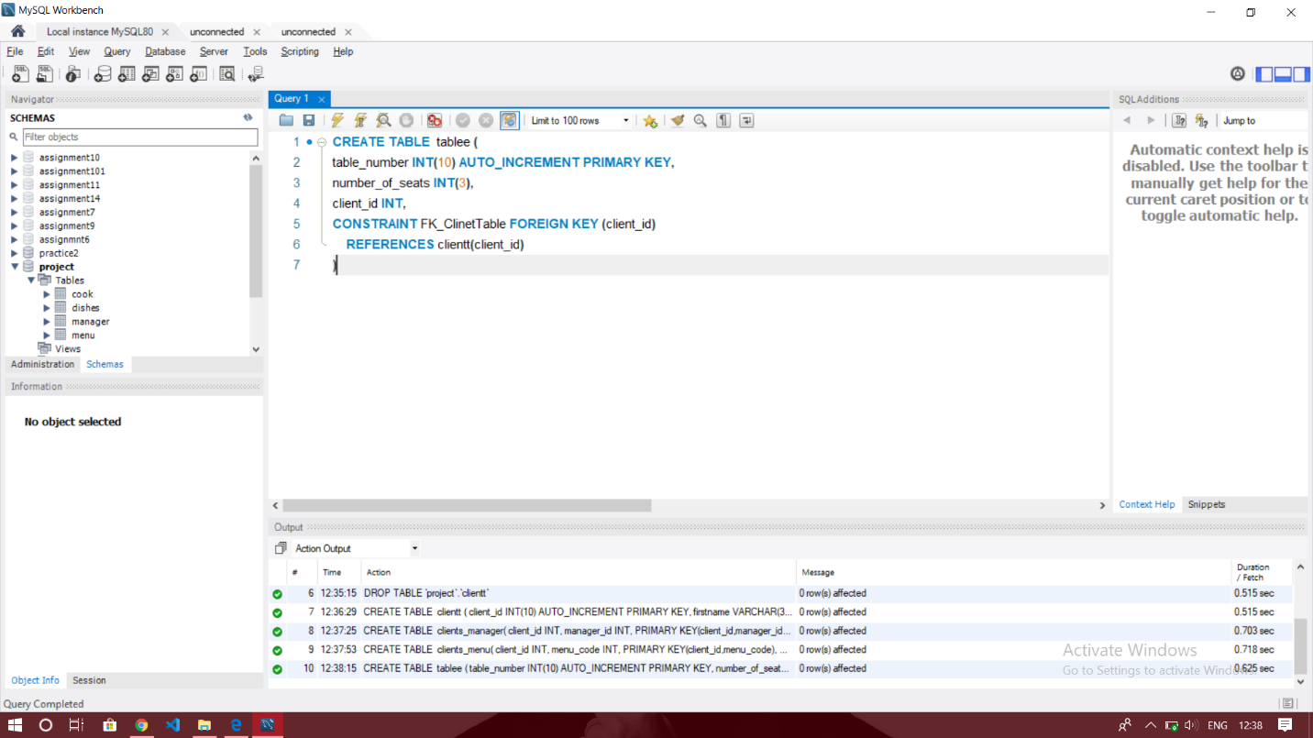

Inserting Data:

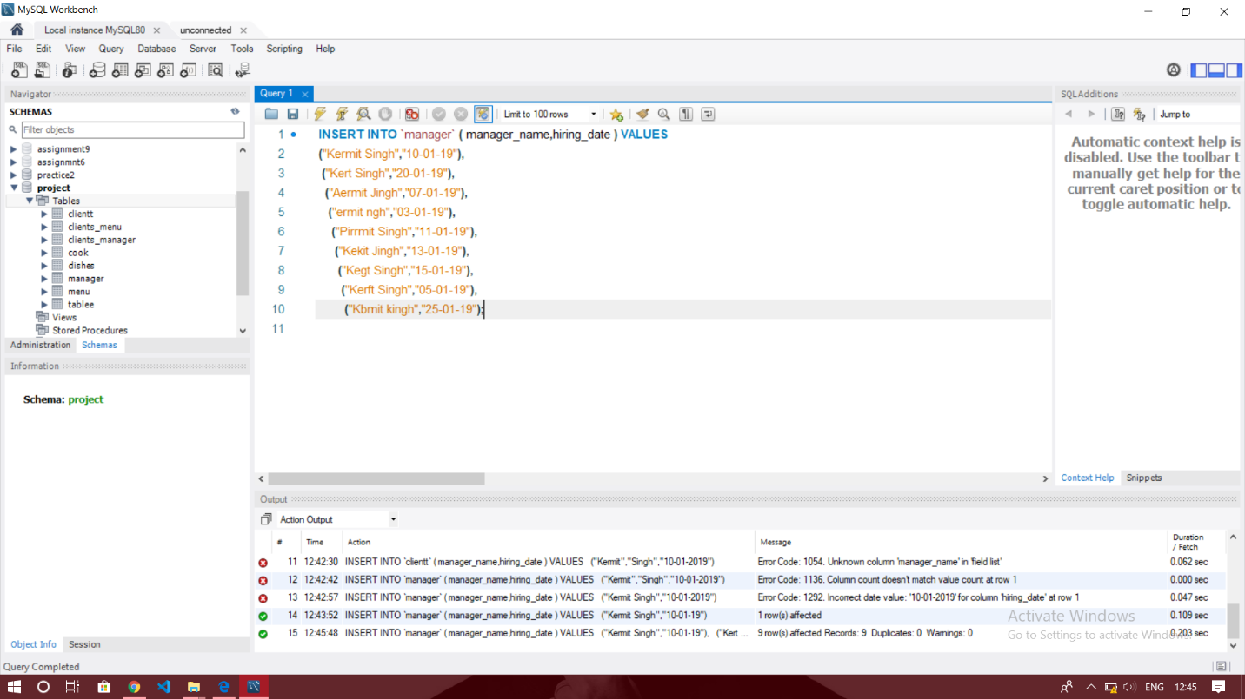

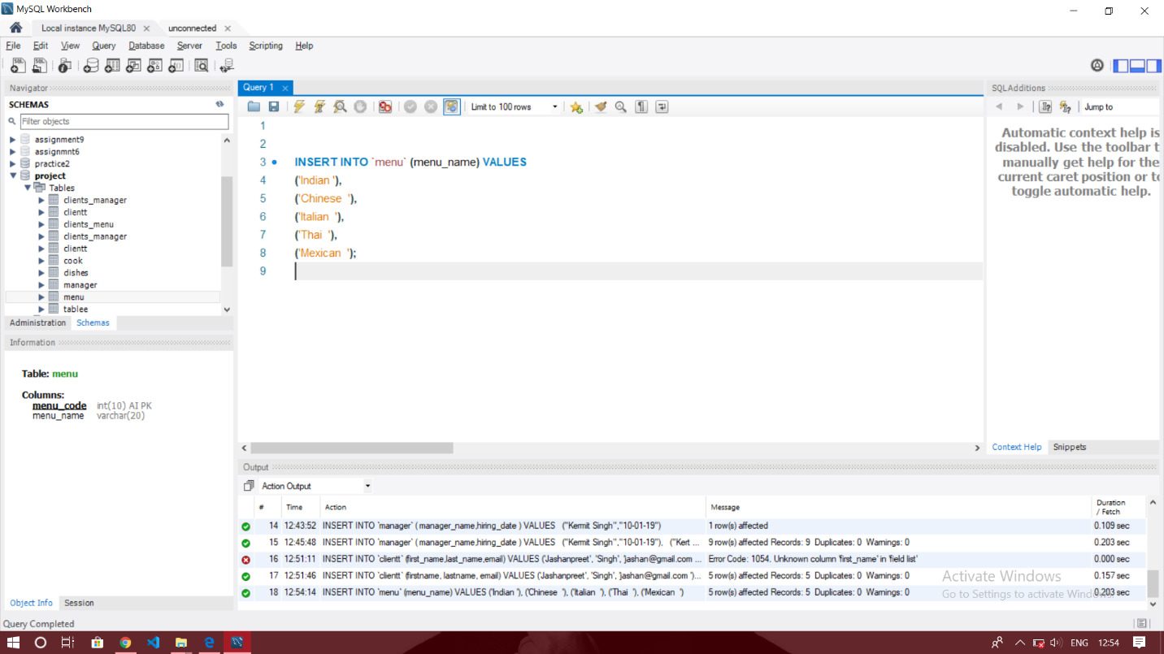

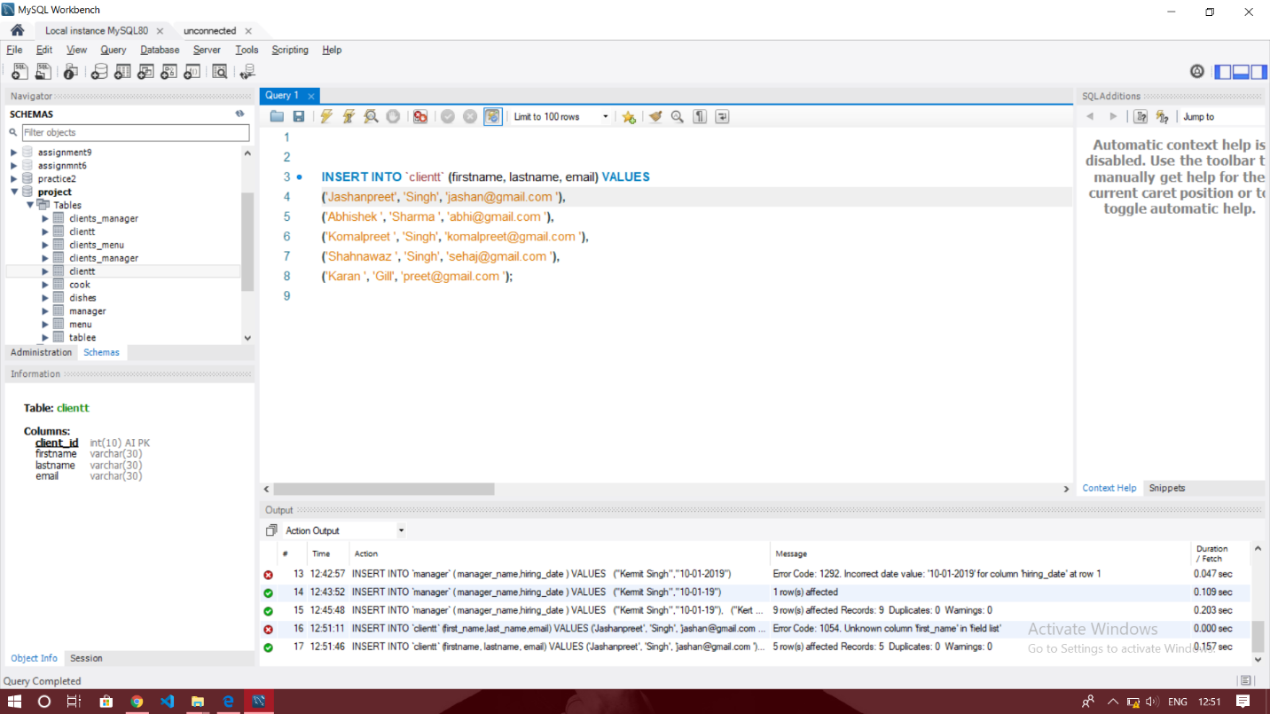

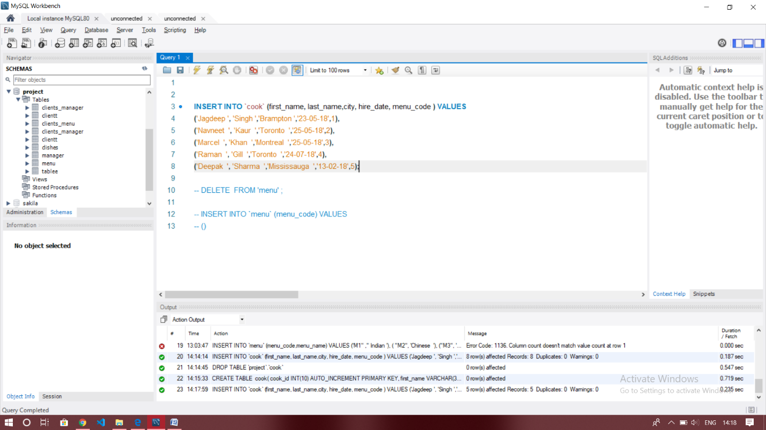

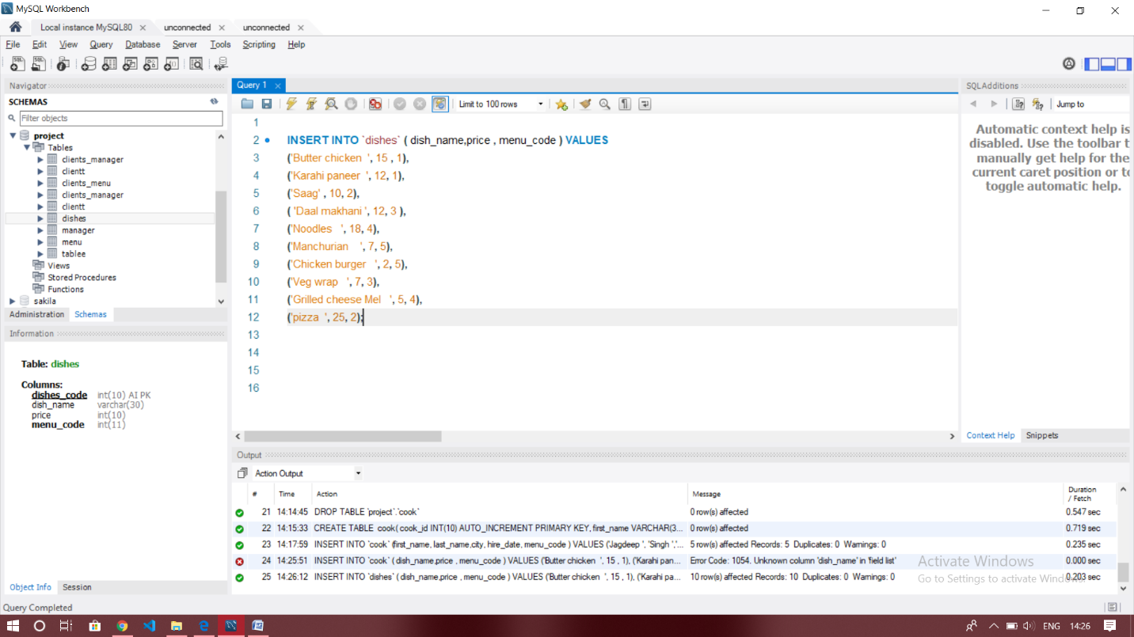

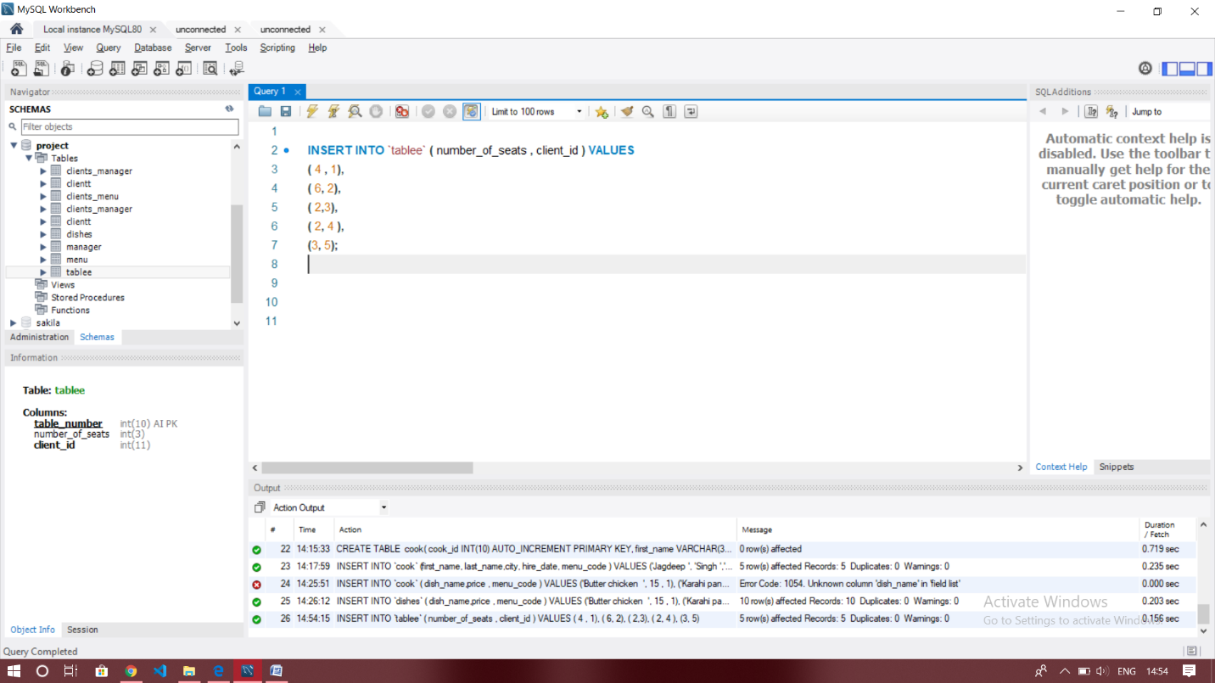

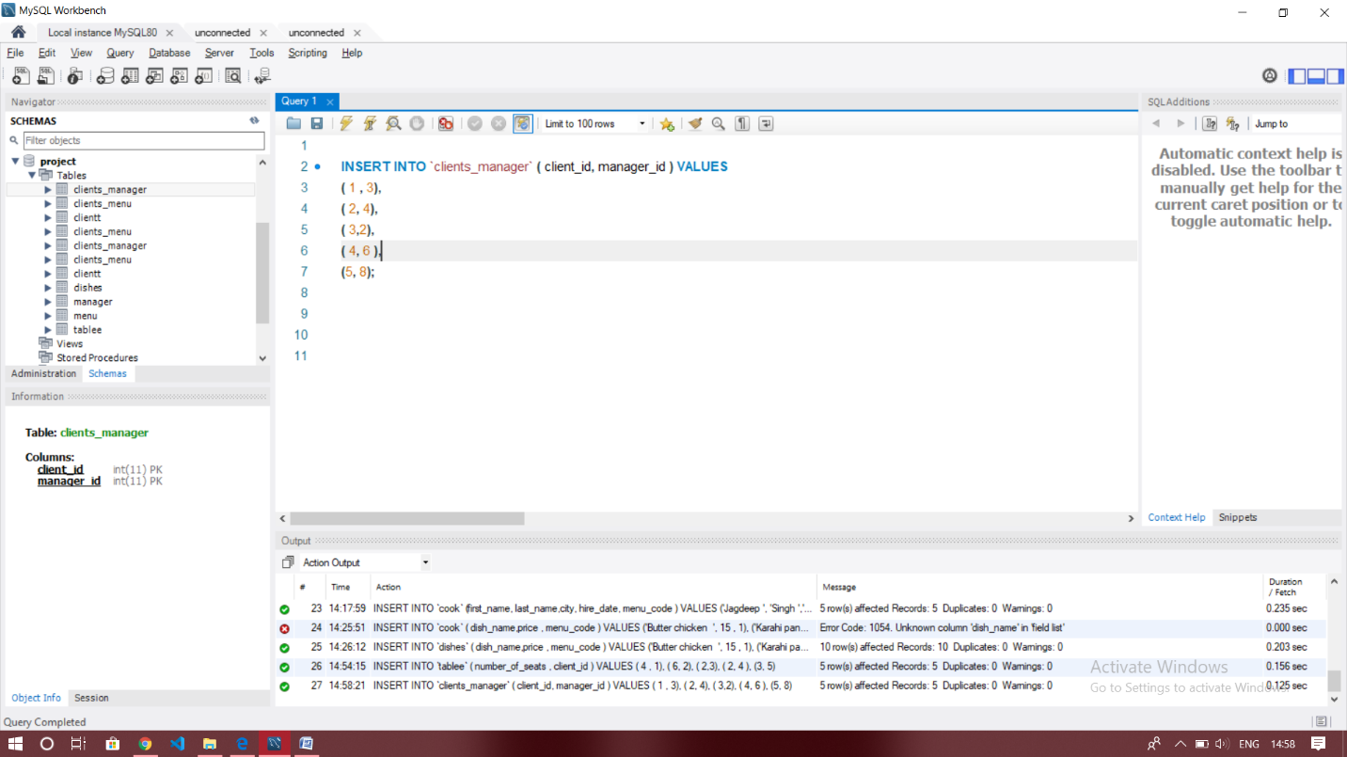

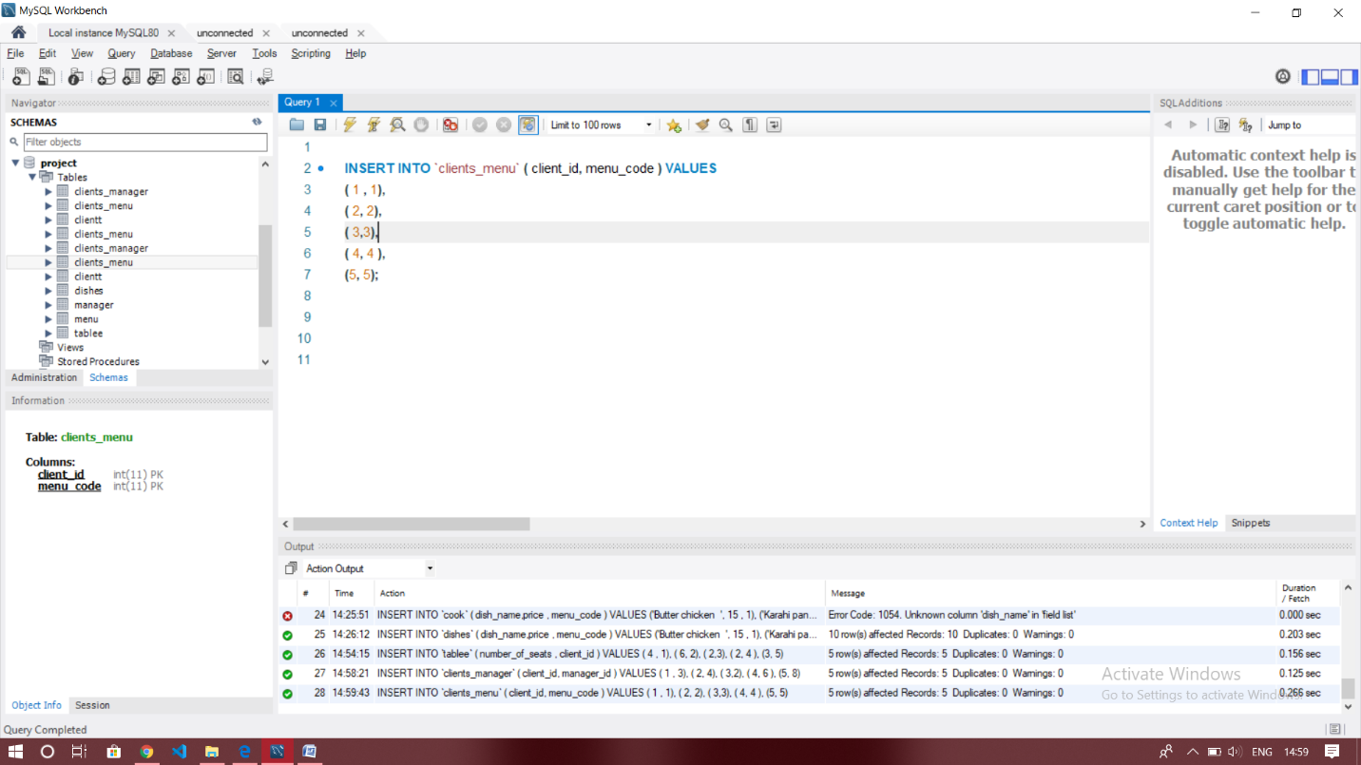

ANALISIS QUERIES :-

